**Topics: Normal distribution, Functions of Random Variables**

1. The time required for servicing transmissions is normally distributed with *μ* = 45 minutes and *σ* = 8 minutes. The service manager plans to have work begin on the transmission of a customer’s car 10 minutes after the car is dropped off and the customer is told that the car will be ready within 1 hour from drop-off. What is the probability that the service manager cannot meet his commitment?
2. 0.3875
3. 0.2676
4. 0.5
5. 0.6987

*μ* = 45, *σ* = 8

the work begins 10 mins after the car is dropped,

the time left to complete work is 50 mins.

Probability that service manager cannot meet his commitment

= P(x>50)

= 1- P(x<=50)

Here x is the time taken to complete the work.

Convert to 50 to z- score

Standard normal variable Z = (X- *μ*)/*σ*

=(x-45)/8

= (50-45)8

= 0.625

Z -calculated value = 0.625

Then in the z -table the value is 0.73232

PR=(z<=0.625) = 0.7323 = 73.237%

Probability that service manager will not meet his commitment is

100-73.237 = 0.2676

So, the answer is B. 0.2676.

1. The current age (in years) of 400 clerical employees at an insurance claims processing center is normally distributed with mean *μ* = 38 and Standard deviation *σ* =6. For each statement below, please specify True/False. If false, briefly explain why.
2. More employees at the processing center are older than 44 than between 38 and 44.

Probability of employee >44=P(x<44)

=1-P(x<=44),

i.e., the above statement is true.

1. A training program for employees under the age of 30 at the center would be expected to attract about 36 employees.

Probability of employees less than the 30 = P (x<30),

i.e., the above statement is true.

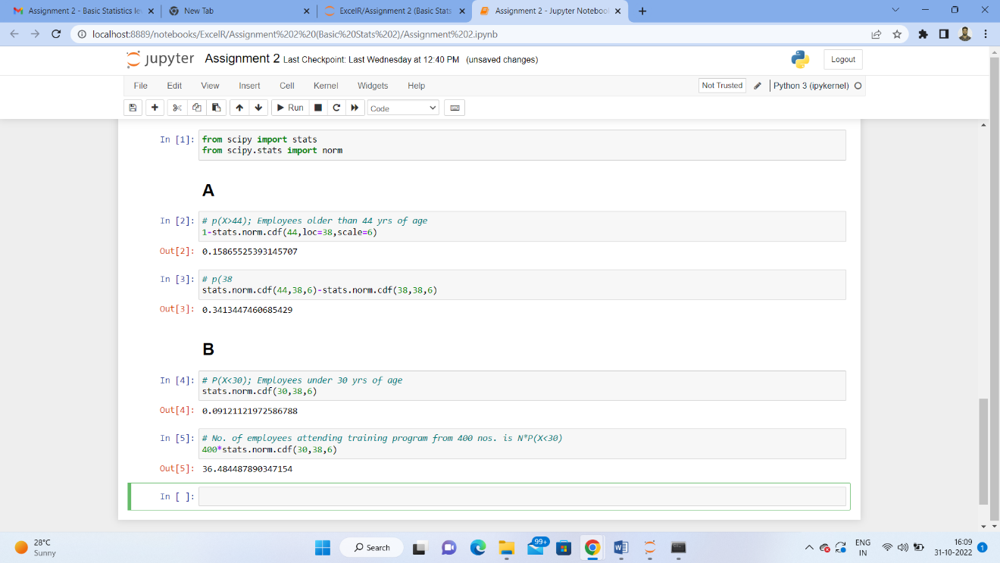

1. If *X1* ~ *N*(μ, σ2) and *X*2 ~ *N*(μ, σ2) are *iid* normal random variables, then what is the difference between 2 *X*1 and *X*1 + *X*2? Discuss both their distributions and parameters.

If X1 ~ N (μ, σ^2)

X2 ~ N (μ, σ^2) these are two independent random variables.

2x1: -

2x1~N (2 μ1,4 σ^2)

X1+X2: -

X1+X2~N (μ1~ μ2, σ^2 +σ^2) ~N (2 μ,2 σ^2)

2X1~(X1+2X1) = N (4 μ,6 σ^2).

The difference between the two says that the two given variables

are **identically** and **independently** distributed.

1. Let X ~ N(100, 202). Find two values, *a* and *b*, symmetric about the mean, such that the probability of the random variable taking a value between them is 0.99.
2. 90.5, 105.9
3. 80.2, 119.8
4. 22, 78
5. 48.5, 151.5
6. 90.1, 109.9

Probability of getting value between a and b is 0.99.

So, the probability getting outside value a and b is = 1-0.99 = 0.01

Probability towards left of a = -0.01/2 = -0.05

Probability towards right of b = 0.01/2 = 0.05

By finding the Standard Normal Variable (z), need to calculate X:

Z = (X-*μ*)/ σ

For a probability of 0.005, z value is -2.57

Z* σ+ μ=x

(-2.57) *20+100=151.4

(-2.57) *20+100=48

i.e., the correct option is D.

1. Consider a company that has two different divisions. The annual profits from the two divisions are independent and have distributions Profit1 ~ N(5, 32) and Profit2 ~ N(7, 42) respectively. Both the profits are in $ Million. Answer the following questions about the total profit of the company in Rupees. Assume that $1 = Rs. 45
2. Specify a Rupee range (centered on the mean) such that it contains 95% probability for the annual profit of the company.
3. Specify the 5th percentile of profit (in Rupees) for the company
4. Which of the two divisions has a larger probability of making a loss in a given year?

